Application for funding from University of Tartu ASTRA project PER ASPERA Doctoral School of Information and Communication Technologies
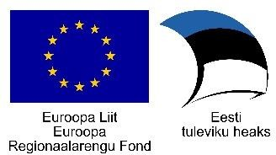

Funding for covering PhD students transportation, accommodation and participation costs

PhD student:
(first and last name)
Contacts:
(e-mail, phone)
Thesis:
(topic, supervisor)

VISIT
Expected dates of the trip
Destination |  | Receiving organization/university
Purpose
Way of participation (presentation – oral presentation, poster or other, topic, authors)
Visit’s contribution to your PhD thesis
Additional information
BUDGET
Travel |  |  | EUR
Accommodation |  |  | EUR
Participation fee |  |  | EUR
Other …………………… |  |  | EUR
Total cost |  |  | EUR

Self-financing 5,00% will be covered from the financial account

The holder of the
financial account
(name, signature, date)

I hereby confirm to follow UT regulations in organizing the visit supported by ICT doctoral school and follow University of Tartu ASTRA project PER ASPERA acknowledgement requirements when participating in a conference or other event.

Applicant
(name, signature, date)

